Task 2

VNet, Subnet, GatewaySubnet, VPN Gatway, VNet-Vnet Connection, Vnet-Vnet Peering using CLI

1. Created a Resource group

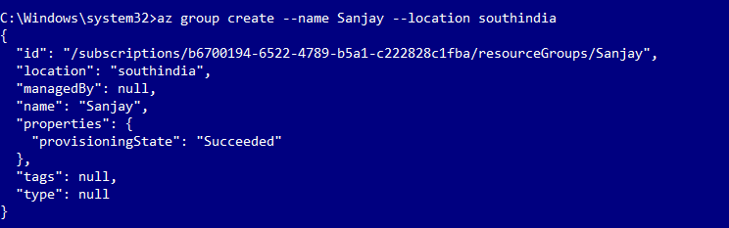

1. Created 3 Virtual Networks

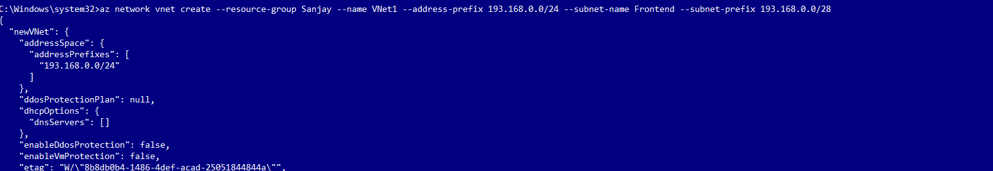

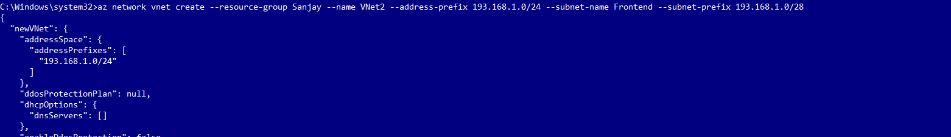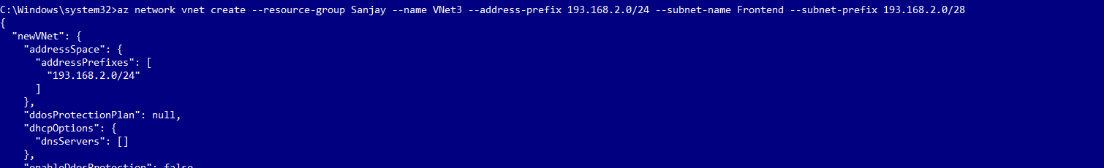

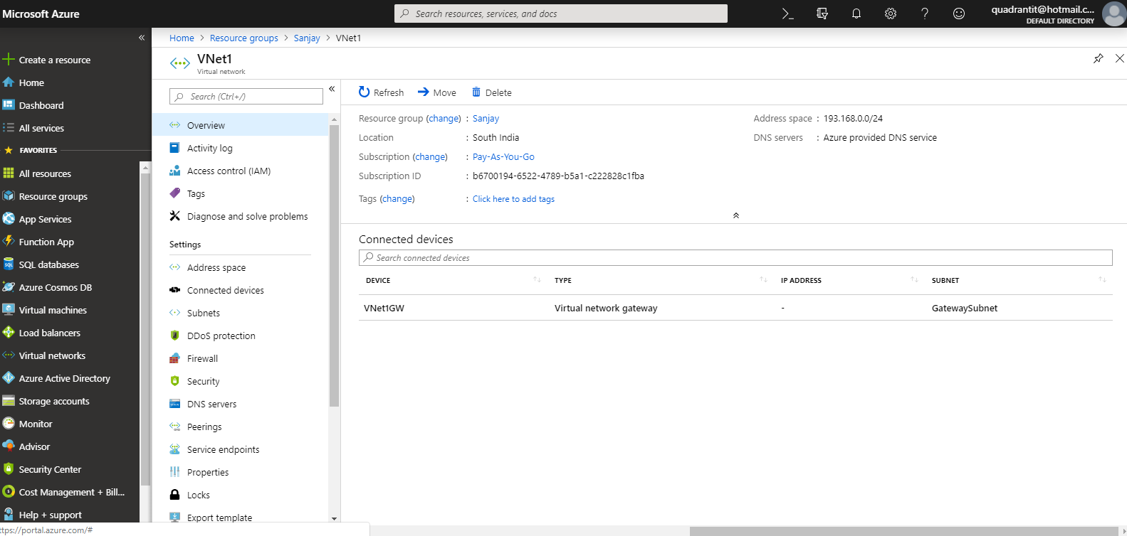

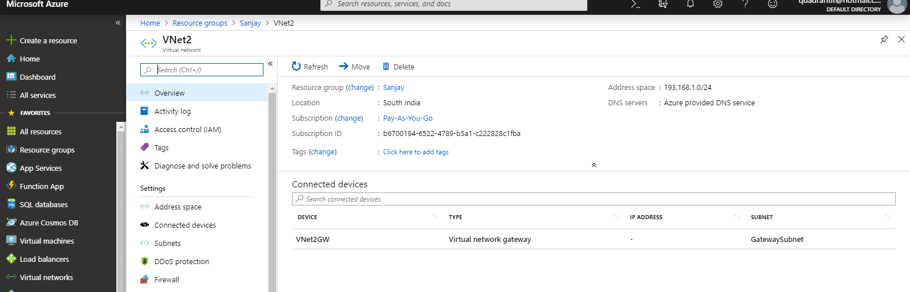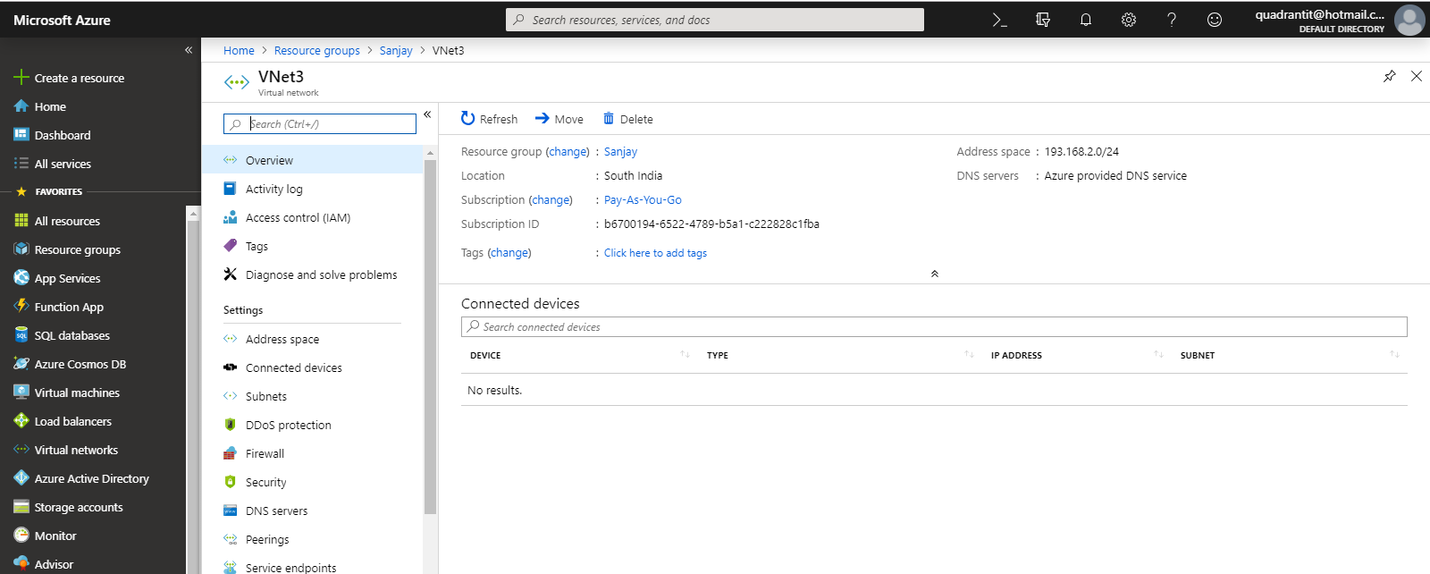

1. Created 3 Frontend ,Backend ,Gateway Subnets for each VNet.

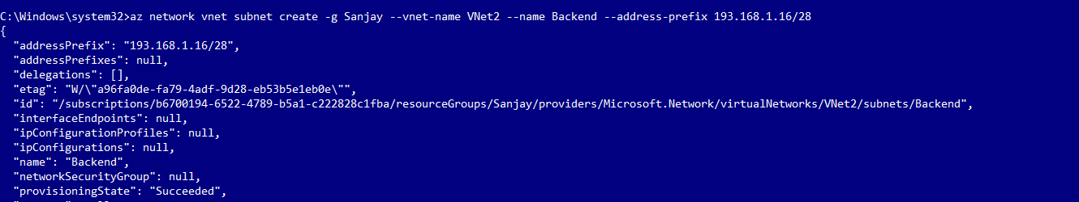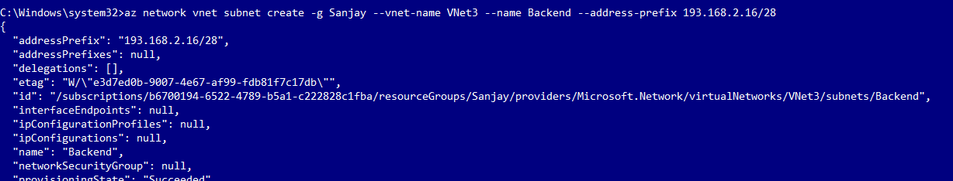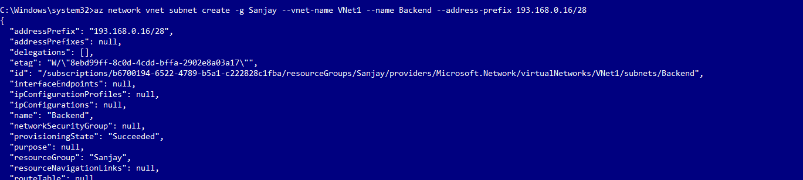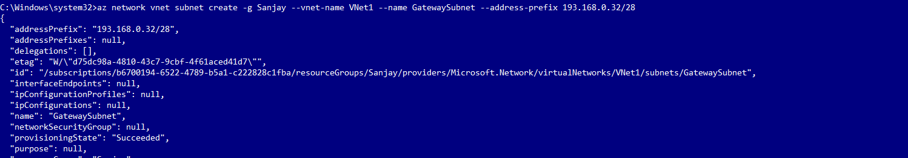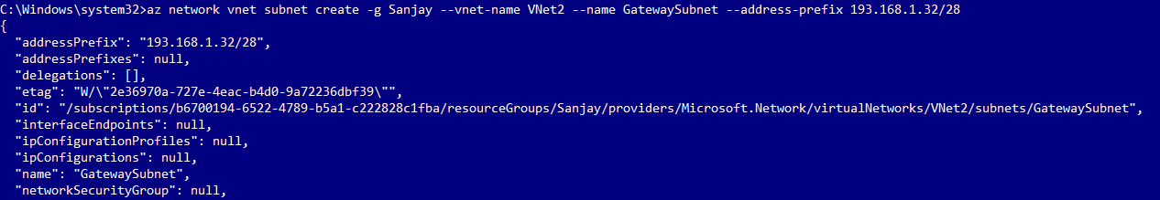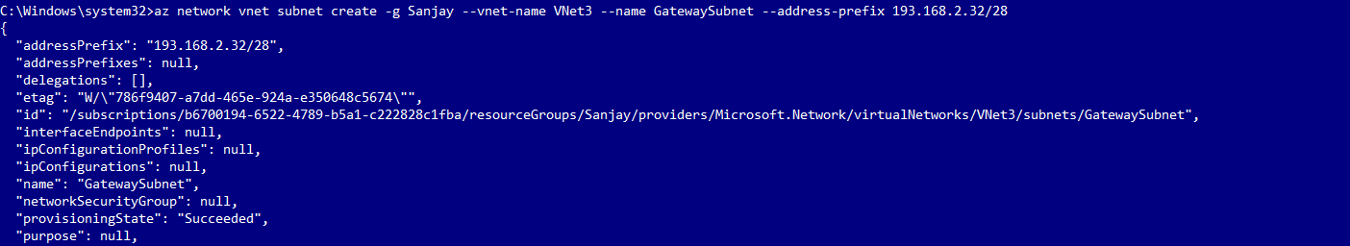

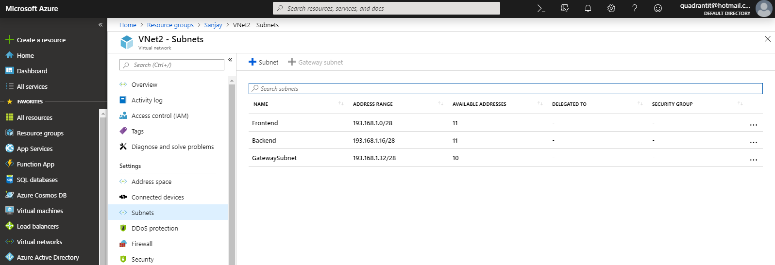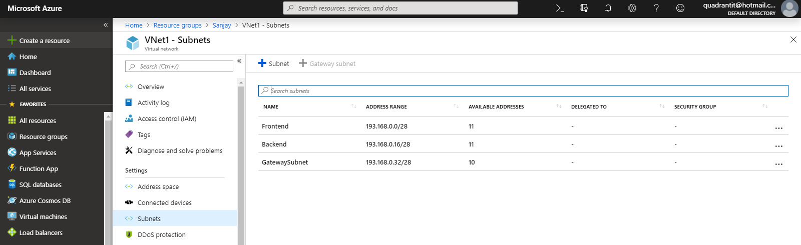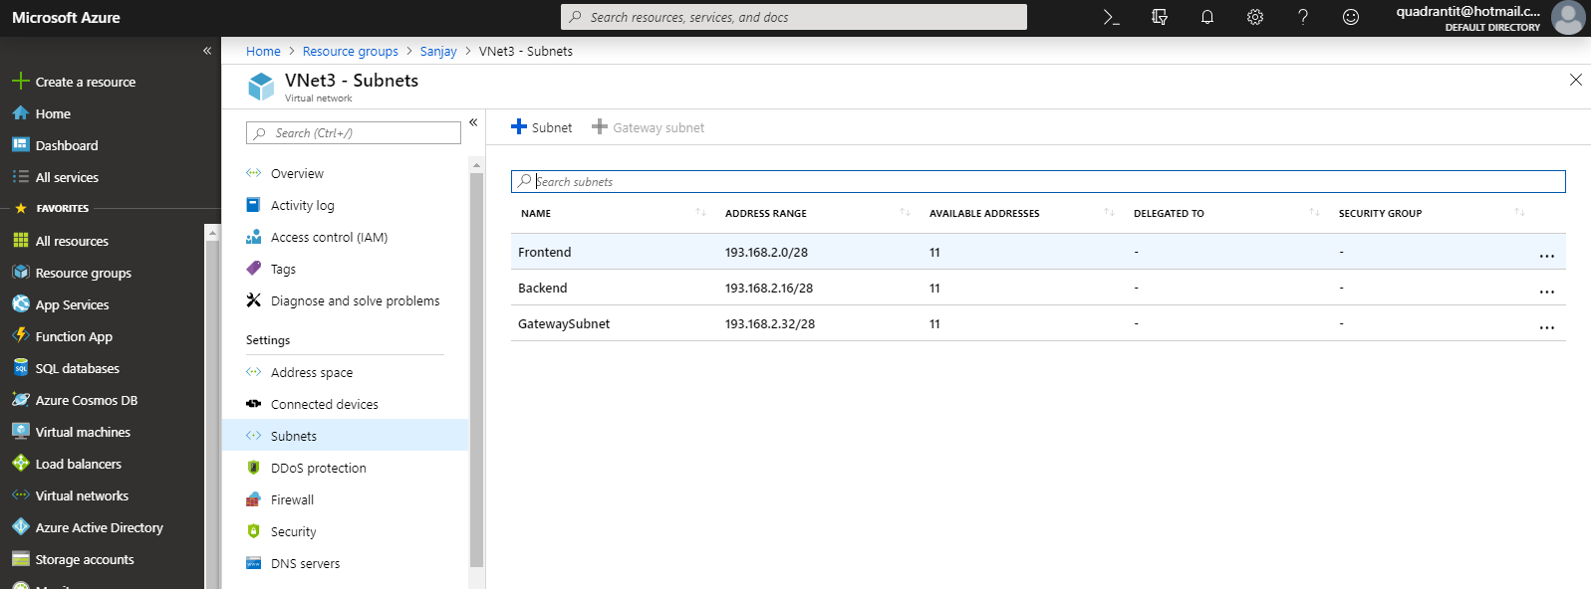

1. Requesting public IP for VNet1 and Vnet2.

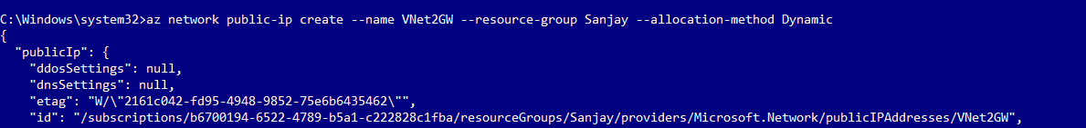

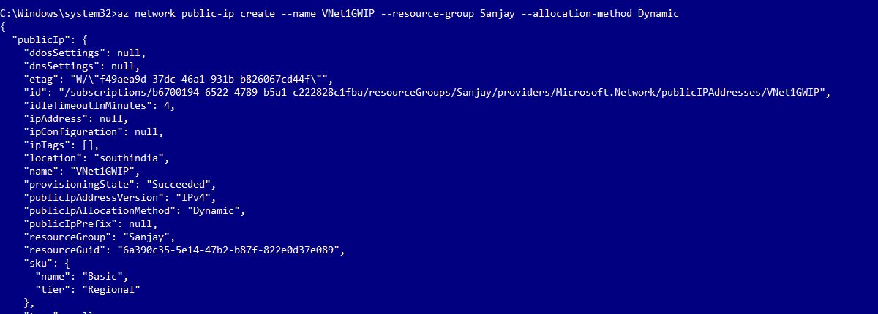

1. Creating VPN Gateways for VNet1 and VNet2.



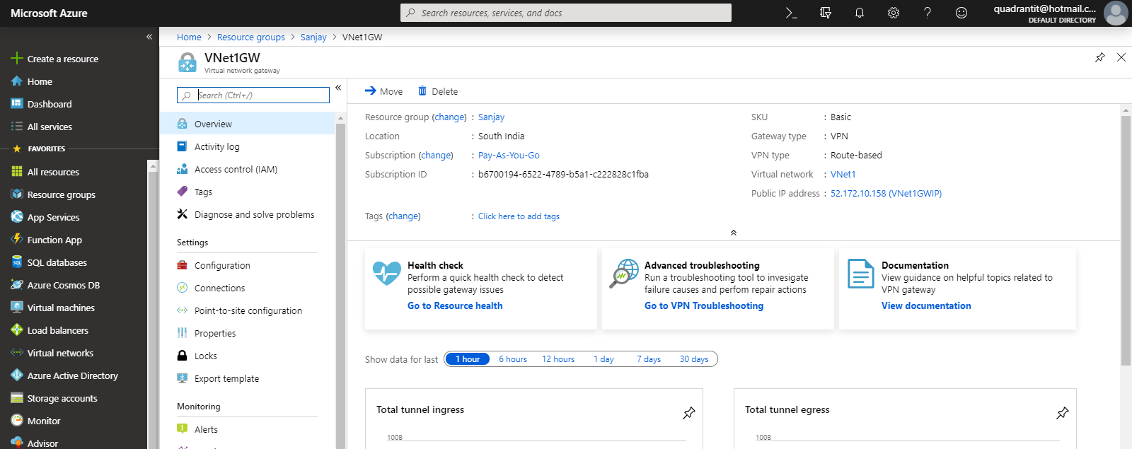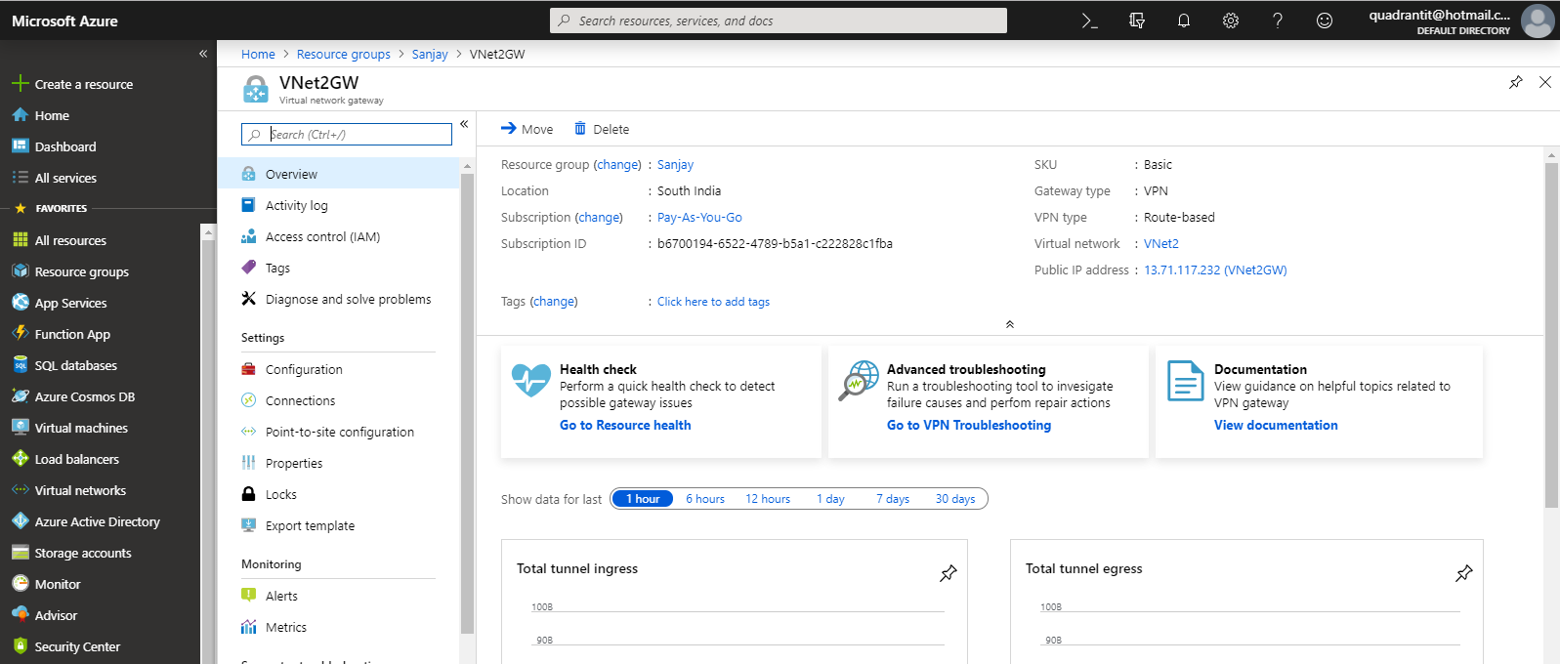

1. Created a Vnet-Vnet Connection for Vnet1 and Vnet2

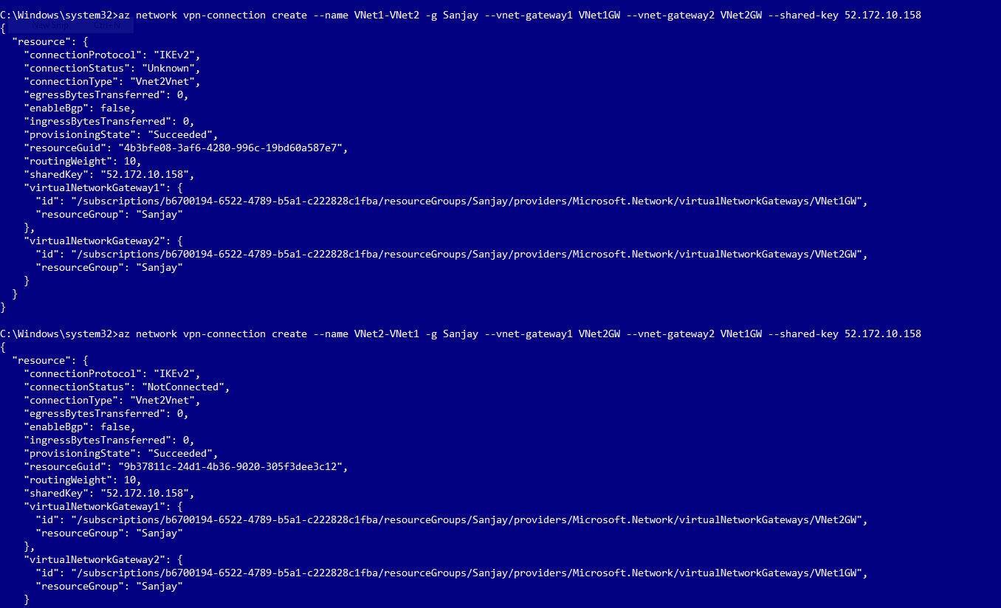

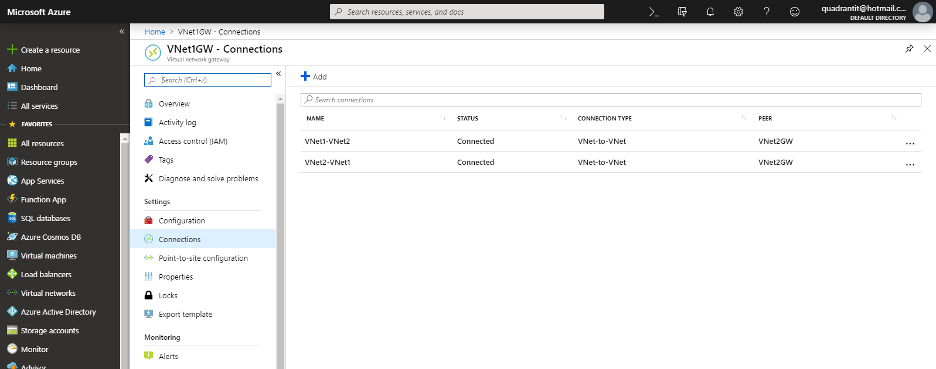

1. Created a VPN Peering for VNet2 and VNet3 and made VNet2 as Hub and VNet3 as Spoke.

